2.0 Chapter 2
Literature Review

2.1 Introduction
This Literature review is to lay out and evaluate ground-centric processing against bounded orbital-edge processing when communications in a degraded or contested environment. The analysis takes a practical approach to and with satellite communications architectures and its traditional reliance on ground-based processing. From that point onward the Literature Review moves into onboard computing, orbital-edge concepts, and the growing use of AI/ML among satellites, space vehicles and potentially Lunar, Martian and self-directing Von Neumann space probes or clusters. This analysis reviews and considers what happens when those communications paths degrade under natural (or man-made) conditions.

Degradation is understood here as lag/delay/latency, reduced bandwidth, packet loss, spotty connectivity or outage, and how those conditions impact or otherwise change the performance and resilience of the larger system, how and in which way.

The method of a Discrete-Event Simulation (DES) provides the analytical framework for bringing all these considerations within a singular, bound and limited rubric. The literature on DES is therefore examined as a way to represent queues, constrained resources, changing communications states, processing delays, and the movement of information through both ground-centric and orbital-edge architectures. Empirical communications, environmental, and AI/ML data are considered within the scope of the research as they are currently priorities to the real-world problems described.

That is to say latency, increased cost, degraded quality etc must be modeled within the framework of the study to specifically address the concerns of the problem. Simultaneous events from multiple data sources grounds the model in conditions that have actually occurred thereby repeating those conditions across both architectures for comparison.

The literature review is divided by six areas: ground station processing; orbital-edge and onboard triaging; communications resilience; DES as the analytical framework; AI/ML, communications, and environmental events as inputs; and the research gap that emerges from within these areas.

The boundaries between these topics have been challenging. Much of the data was varied and needed to normalized in order to contribute to more than one part of the review because their methods, datasets, or findings address multiple portions of the architecture. Altogether, the literature provides the technical and methodological basis for examining, learning and understanding where processing occurs, how degraded communications affect system behavior, and whether bounded processing at the orbital edge changes system performance under those conditions.

The main sources introduced in this section include the NASA SCaN architecture, the satellite communications survey by Kodheli et al., RAND work on communications resilience, OPSSAT-AD, the WetLinks dataset and associated research, and NASA OMNI environmental data.

2.2 Ground-Centric Satellite Communications and Processing
The current traditional round-trip satellite architecture depends largely on the connection between the space element/unit and the ground infrastructure associated with it for data transport, processing, analysis, and executive decision support (human-on-the-loop).

NASA's Space Communications and Navigation set-up provides an existing operational and empirical baseline for articulating a typical ground stations nominal behavior as the use case relevant to this study. Therefore, all related or associated relay networks, their indigenous communications routes, and necessarily user segments are within the scope of this analysis. The architecture itself establishes the indigenous and associated components to the communications ecosystem as a resource.

NASA's SCaN material thus supports the baseline Ground-centric path used in this Praxis. The associated satellite communications literature defined in this study uses latency, bandwidth, routing, visibility, and network availability as prioritized characteristics of modern satellite systems this study is concerned with.

The information pulled into the scope of this research, that is to say, Kodheli et al. therefore provide the relevant, contextual and empirical technical detail for the satellite-network use case being analyzed. In this case, the implementation of onboard processing to reduce cognitive burden.

Next WetLinks provides empirical evidence that operational LEO communications exhibit measurable variations in round-trip time, throughput, packet loss, routing, and other network characteristics.

WetLinks is useful as the data network measurements were collected along with weather observations. This made it relevant both to communications performance and a later review and analysis of the environmental context.

Within this paper, the degradation in performance can also be interpreted as denial or artificial degradation via man-made sources. arXiv Sources/citations for this section - National Aeronautics and Space Administration. (2013).

Space Communications and Navigation (SCaN) Network Architecture Definition Document: Executive Summary, Volume 1, Revision 4. - Kodheli, O., Lagunas, E., Maturo, N., et al. (2021). Satellite communications in the new space era: A survey and future challenges. IEEE Communications Surveys & Tutorials, 23, 70–109. - Laniewski, D., Lanfer, E., Meijerink, B., van Rijswijk-Deij, R., & Aschenbruck, N. (2024). WetLinks: A Large-Scale Longitudinal Starlink Dataset with Contiguous Weather Data. TMA 2024. https://doi.org/10.23919/TMA62044.2024.10558998 - WetLinks dataset/repository: dataset DOI 10.26249/FK2/YXPS4G; GitHub sys-uos/WetLinks.

[Insert here) Ex. PowerPoint figure: Figure 2-1. Ground-Centric Processing Path (The RGS) – the downlink queue and communications link – back to Decision/Operator Output. OV-1 here. (TBD)
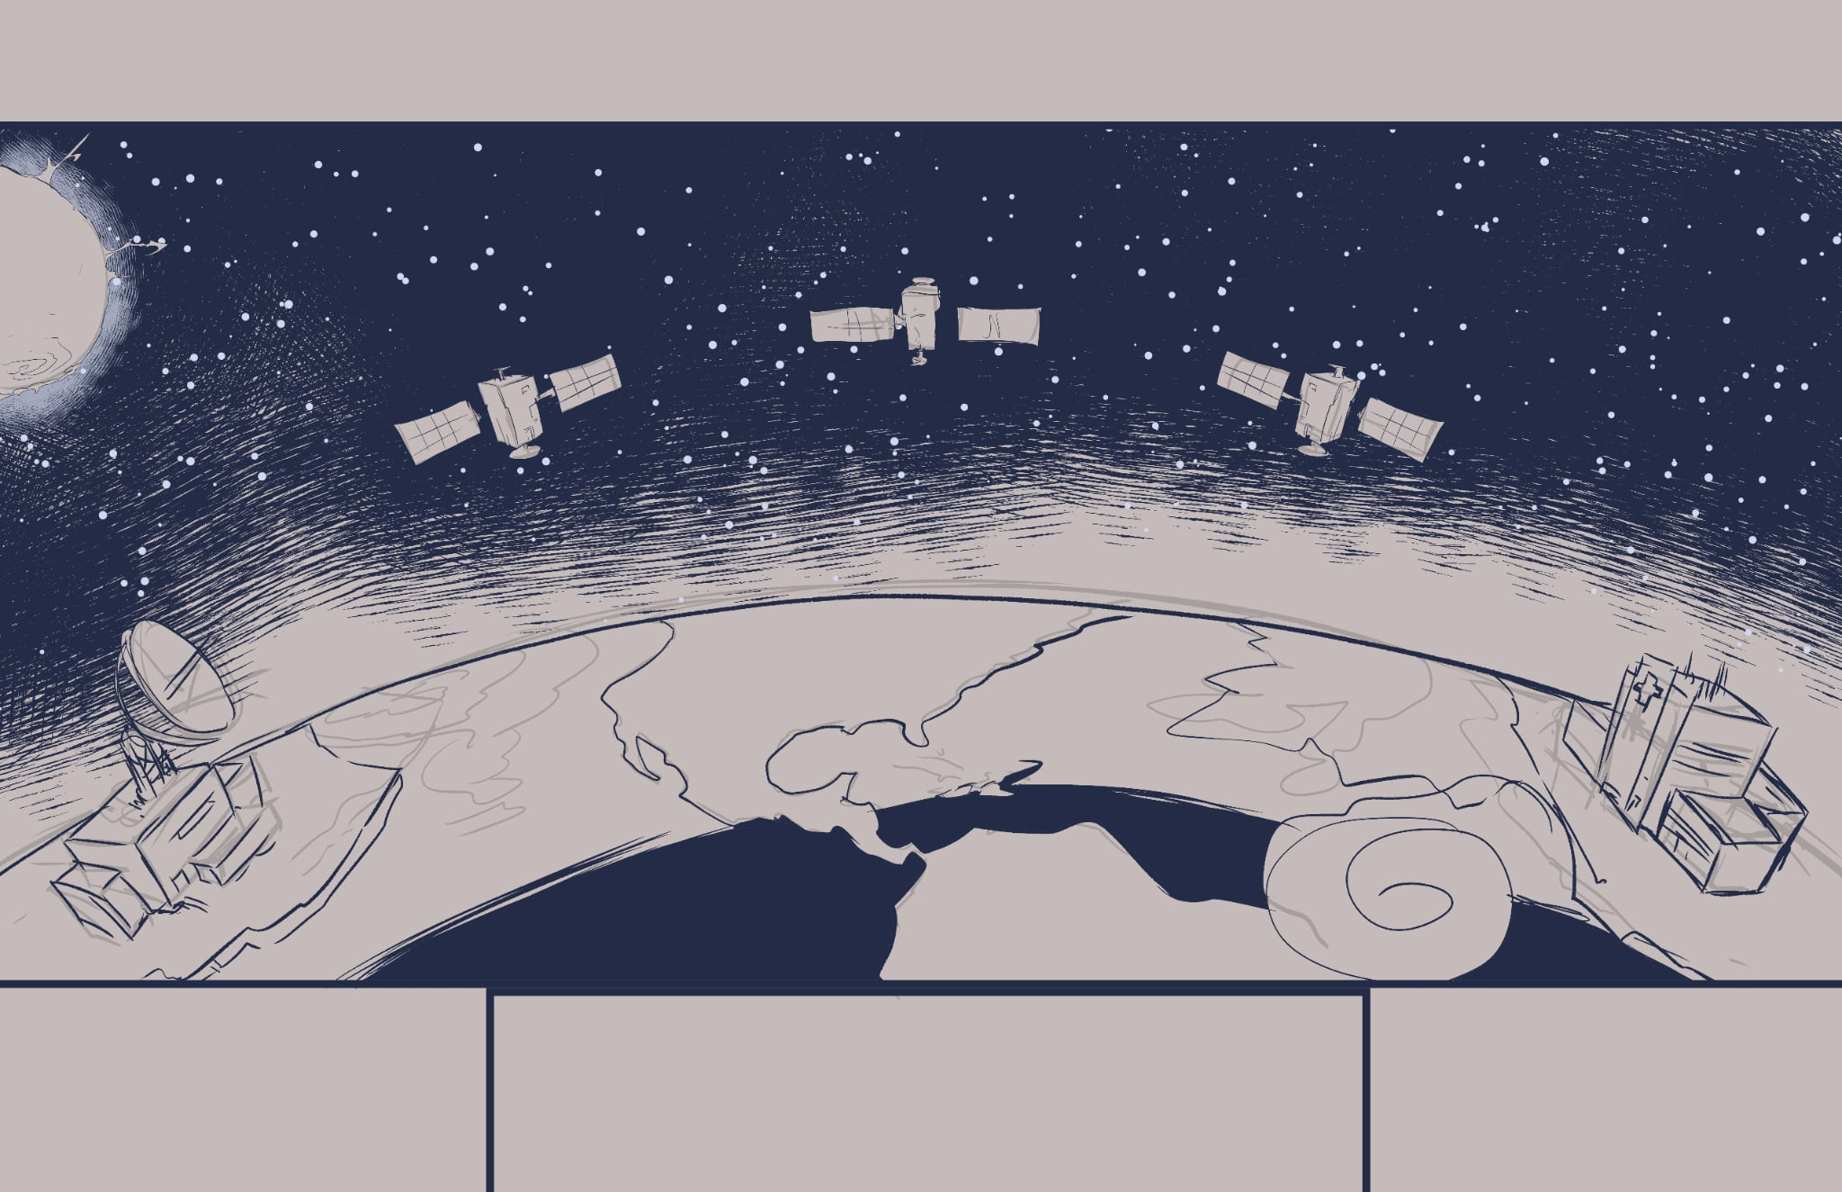

2.3 Orbital Edge Processing and Bounded AI/ML
Orbital edge processing, much like Gemba Walks, move selected computational functions from the User/Organization/Operator/Agent closer to the point where observations are generated and decisions executed. Candidate functions include filtering, compression, anomaly detection, prioritization, and other bounded processing activities from the Operator/Agent that can reduce the amount of information requiring immediate transmission to the ground and reducing cognitive burden.

Potential system-level benefits to the ecosystem:

Reduced Latency: By performing processing on on-board satellites, this capability seeks to reduce the time it takes to transmit data back to earth and send/receive a response in order to reduce decision fatigue, optimize resources and increase the AGILE/OODA Loop tempo for the Operator/Agent. This capability can be of acute importance for tasks requiring real-time or near-real-time processing, i.e. remote sensing, PNT navigation, deconfliction, safety of flight or other critical triaging of tasks.

Improved Data Quality: Image data can be compressed or filtered on-board the satellite, reducing the amount of data requiring transmission and improving the overall quality of the data.
Reduced Bandwidth: By processing the data on-board the satellite, the amount of data that needs to be transmitted can be reduced, freeing up valuable bandwidth for other uses.

Increased Autonomy: On-board processing can also allow the satellites to operate independently for longer periods of time without the need for constant communication with ground stations.

Cost-effectiveness: On-board processing can also be cost-effective, as it reduces the need for expensive ground infrastructure and allows for the use of smaller, less expensive satellites.

OPS-SAT provided empirical evidence showing how comparative onboard computing and AI/ML autonomous software execution are technically feasible on a small spacecraft. The OPSSAT-AD dataset proceeds to provide real-world evidence by offering labeled spacecraft telemetry segments suitable for the relevant natural/man-made anomaly detection (modeling and SIM) and constituent AI/ML elements. The datasets contain the actual real-world telemetry in segments.csv and labeled segment level features in dataset.csv. This combination made it useful both as an AI/ML workload source and as the chronological bridge for the simultaneous ACE experiment relying on data normalization and formatting.

Outside of the literature purview are claims that onboard processing is automatically advantageous. To be sure, Edge processing introduces its own compute time, resource requirements, and implementation constraints.

The value proposition to the User/Operator/Agent happens at the intersection of trade-offs between onboard processing cost(s), communications conditions, workload, and the amount of downstream data that can be optimally reduced and/or prioritized.

Citations for this section
- Ruszczak, B. (2024). OPSSAT-AD [Data set]. Zenodo. https://doi.org/10.5281/zenodo.15108715
- Ruszczak, B., Kotowski, K., Nalepa, J., & Evans, D. (2024).
- ESA OPS-SAT mission / telemetry data
- NASA/JPL Autonomous Sciencecraft Experiment as historical onboard analysis/planning precedent.
- Fridley for orbital AI/human workflow, Busart for distributed edge/bandwidth architecture, and Smith for constrained edge inference

PowerPoint figure (TBD)
Figure 2-2. Ground-Centric versus Bounded Orbital-Edge Architecture (will design and provide an image.)

2.4 Degraded Communications, Environmental Conditions, and Resilience
Communications degradation can appear here as increased latency, reduced capacity, intermittent connectivity, packet loss, congestion, or complete periods of unavailability. These effects here is compounded due to the ground-dependent processing architecture not completing its processing path until the dependency of required/requested information successfully crosses the satellite/Operator-Agent communications link.

Resilience as a quality is dependent on whether useful satellite-ground service can be kept within an operationally relevant time threshold to the User.

Throughout this evaluation, the data sets containing environmental conditions provided strong, native, real-world sources of communications friction that could be measured. In turn this data was used to observe how the datalinks behaved during such natural degradation, disruption and/or decay. To be sure the environmental measurements and human made network-performance measurements have been kept analytically distinct despite yielding the same outcome. Loss or degradation of service.

For the natural phenomena NASA OMNI provides high-resolution solar-wind, interplanetary magnetic-field, and geomagnetic-index data at one- and five-minute resolution, including magnetic-field components, solar-wind speed and density, AE, and SYM/H. OMNIWeb

An earlier hybrid model also used CINC ionosonde observations from Chile and King George Island (Antarctica) as an environmental data-fit source.

Those records showed how ionospheric measurements (e.g. foF2, fmin, M(3000)F2, hmF2, and TEC) can be normalized into the model, while WetLinks showed how communications metrics and colocated weather observations can be analyzed together. Neither source justifies treating temporal coincidence as causation.

Sources for this section
NASA Space Physics Data Facility. OMNIWeb High Resolution OMNI. NOAA/NCEI space-weather products for environmental/event context. Centro de Instrumentación Científica (CINC), Universidad Adventista de Chile - ionosonde archive / meteorologiaespacial.cl; numerical data package provided by Manuel Alejandro Bravo Sepúlveda, Sept. 21, 2026. Laniewski et al. (2024), WetLinks. Osoba et al. (2023), RAND Resilience Assessment Framework.

PowerPoint table: Table 2-1. Degraded Condition - DES Representation - Measure (TBD)
Condition DES representation Principal measure
Increased communications delay Longer link service time End-to-end latency
Reduced link capacity Lower service rate Queue delay
Intermittent connectivity Resource availability changes Service availability Outage COMM resource unavailable Downtime/recovery
Workload surge Increased arrival rate Queue growth
Edge filtering/reduction Reduced downstream data demand Bandwidth / latency
2.5 Discrete-Event Simulation (DES) for Architecture Evaluation
A Discrete-Event Simulation (DES) is appropriate model for when system performance is dependent or otherwise reliant on the timing and sequence of unique moments or events, competition for finite resources (time/cost/quality), queuing formation, processing bottlenecks and delays, interruptions/disruptions, and recovery.

The qualities mentioned above surround the Ground versus Edge architecture described in this Praxis. Observations can be represented as: entities arriving over a period of time, requests for information (RFI’s) entering queues, and competition for communications and processing resources terminating in a recommendation, solution or analysis for the operator to make an informed and timely decision.

Several useful methodological analogues were found within the GWU Praxis literature Research Gate.
Several relevant and analogous use cases were found, among were the following.
Browne used DES and Monte Carlo methods to study arrivals, utilization, congestion, and waiting time. Littlefield applied DES to distributed system reliability and common cause failures.

Shanbhag used generative DES to examine finite compute resources and overloaded cloud workloads. Competition for resources.

Newell applied DES to operational availability and failure/repair behavior which speaks to resilience.

Devineni used DES and Monte Carlo analysis to review the relationship between a process wait time and the associated resolution time as a result.

These works do not model orbital edge processing but they provide successful precedents for the queueing, resource, degradation, replication, and sensitivity-analysis mechanisms key to analysis of the problem here.

Sources
- Browne (2024) - DES/Monte Carlo; arrivals, utilization, waiting.
- Littlefield (2017) - DES reliability, failures, redundancy.
- Shanbhag (2021) - DES of finite compute resources and overload.
- Newell (2023) - DES, failures, repair, operational availability.
- Devineni (2023) - DES/Monte Carlo, waiting and resolution time.
- Reid (2018) - MATLAB/Simulink, Monte Carlo, sensitivity and V&V.

PowerPoint figure:
Figure 2-3. Conceptual DES Architecture (TBD)

  - Application of Data Fusion for the AI/ML, Communications, Environmental (ACE) Framework

The framework used in this Praxis amalgamated/fused three unique data buckets.
AI/ML telemetry, (OPSSAT-AD v2, dataset.csv, segments.csv), Communications data, (SatNOGS OPS-SAT telemetry, OPS-SAT_2022-01-26_to_2022-01-29_COMPLETE.json), Environmental measurements, (NASA OMNI 1-minute space-environment data, 28 Jan 2022, ~17:42–17:55 UTC)

The purpose of fusion is to normalize the aggregated datasets together.

The sources selected are normalized by timestamp, field meaning, units, provenance, and quality state. Once these fields are agreed upon can they be mapped into common simulation runs.

The original hybrid prototype excel model demonstrated the intake process using OPSSAT-AD for AI/ML. In turn WetLinks was used for communications, and CINC ionospheric measurements for the environmental context of data performance. Since those streams were collected during different time periods, they were treated as independent sources versus simultaneous observations to stress test the model in the first place.

The simultaneous ACE prototype advances that design however by using three sources associated with the same OPS-SAT period:

AI/ML — OPSSAT-AD v2. dataset.csv provides the labeled and engineered AI/ML segment representation, while segments.csv provides the underlying timestamped OPS-SAT telemetry. OPSSAT-AD contains 2,123 labeled segments and 303,493 underlying telemetry rows. Zenodo
COMM — SatNOGS OPS-SAT telemetry. SatNOGS identifies OPS-SAT as NORAD 44878 and provides timestamped reception data and OPS-SAT telemetry data. The bounded source file used in the model was taken from the SatNOGS telemetry API. The OPS-SAT telemetry data exposes radio-state and counter fields including RSSI-related values and transmitted/received packet and byte counters. SatNOGS DB
ENV — NASA OMNI. High-resolution one minute OMNI data was acquired for the each corresponding UTC period. This source also supplied environmental variables including IMF magnitude, Bz, solar-wind speed and density, and temperature.

Core data citations
- Ruszczak, B. (2024). OPSSAT-AD — anomaly detection dataset for satellite telemetry (v2). Zenodo. https://doi.org/10.5281/zenodo.15108715
- SatNOGS Database. OPS-SAT, NORAD 44878. SatNOGS DB
- Libre Space Foundation. satnogs-decoders — opssat1.ksy.
- European Space Agency. OPS-SAT-1 UHF Telemetry Analysis. This is useful for interpreting fields such as Background RSSI and Last RSSI, but our 2022 model uses the independently harvested SatNOGS records rather than the ESA 2024 re-entry dataset. OPSSAT
- NASA Space Physics Data Facility. OMNIWeb High Resolution OMNI. OMNIWeb
- Laniewski et al. (2024), WetLinks — supporting earlier COMM data-fit precedent.
- CINC / Universidad Adventista de Chile — supporting earlier ENV data-fit precedent.

  - Literature Synthesis, Research Gap, and Praxis Implications

In sum, the literature establishes several key basis for this Praxis.
Satellite operations rely on communications architectures that introduce measurable latency, up-time, and bandwidth restraints/constraints and obligations..
A system that can change the amount and type of information that must traverse the links serving the Operator/Agent via Onboard processing and AI/ML is technically feasible.

Prior research established the feasibility of onboard processing and communications resilience. Further, previous research also showcased the availability of environmental and communications observations, and their suitability to discrete-event simulation for resource-constrained systems.
However, the literature does not fully characterize the performance trade-off between ground-centric and bounded orbital-edge processing when AI/ML, communications, and environmental observations are represented within a synched model.
Individually, all three of these categories have been investigated separately. Communications studies measure network performance, environmental archives measure physical conditions and onboard-processing studies evaluate computation or AI/ML. DES studies evaluate queueing or resource behavior between all three.
DES, supported by the identified ACE inputs, allows this Praxis to close this research gap.
Environmental phenomena is used to describe degradation impacting the related space systems within the contested area of interest.
The DES provides a systematic and evaluative approach for the key qualifiers previously discussed, event timing, resource allocation and management, failures, and recovery.
Ill-characterized are the operational trades between ground-centric and bounded orbital-edge processing when AI/ML tasks are overwhelmed, communications reliability tested, and the key environmental events are peaking inside of simultaneity envelope.

